**A PROJECT REPORT**

**ON**

**“PhoneVerse”**

**BY**

**Sanket Nitin Indore Aditya Dilip Bangar**

UNDER THE GUIDANCE OF

**Prof. Thorat T.M.**

IN PARTIAL FULFILLMENT OF

# DEPATMENT OF BACHELORS OF BUSINESS ADMINSTRATION (COMPUTER APPLICATION)

Under

**University of Pune**

**DEPATMENT OF BACHELORS OF BUSINESS ADMINSTRATION (COMPUTER APPLICATION)**

**Academic Year 2023-2024**



## Annasaheb Awate Arts, Commerce, And Hutatma Babu Genu Science College, Manchar.

**(Savitribai Phule Pune University, Pune)**

**DEPATMENT OF BACHELORS OF BUSINESS ADMINSTRATION (COMPUTER APPLICATION)**

**DEPARTMENT OF BBA(CA)**



CERTIFICATE

This is to certify that Mr. Sanket Indore and Mr. Aditya Bangar BBA(CA)(SEM-IV) class has completed his project work title **“PHONEVERSE”** as part of curriculum, during the academic year 2024-2025.

**Date:**

**Place: Manchar**

**(Prof. Thorat T.M.) ( Sangita Khatal )**

**Project In charge Head of Department**

# ACKNOWLEDGEMENT

I wish to thank you the principal Dr. N.S.Gaikwad sir of my college for permitting to use all the facilities available in the institution for my project work. I would also like to thank the Head of Department BBA(CA), the teaching faculty and all the non-teaching staff of my college for their support in completing the work successfully.

I am grateful to my Internal Guide Prof Thorat T.M. for this encouragement, guidance and supervision of my project work during this year. I express my thankfulness to them. I must acknowledge the support given to this project by Prof Thorat T.M. without which it would have been difficult to complete the work in time.

My classmates have been of great help to me during the project work. My ideas were shaped and refined progressively through my discussions with them from time to time. I cannot miss to thank them all. There were some persons who were not directly but indirectly involved in my preparatory/practical work. I heartly appreciate their contribution and thank them too.

**Your’s Faithfully,**

Indore Sanket Nitin

Bangar Adtiya Dilip

# INDEX

|  |  |
| --- | --- |
| **Sr.no.** | **Topic** |
| **1.** | **Introduction** |
|  | Purpose of system |
|  | Scope of system |
| **2.** | **System Analysis** |
|  | Fact finding technique |
| **3.** | **Feasibility study** |
| **4.** | **Software / hardware specification** |
| **5.** | **System Design** |
|  | Entity Relationship Diagram |
|  | Data Flow Diagram (0 level) |
| **6.** | **File designing** |
| **7.** | **Advantages and Disadvantages** |
| **8.** | **Future Enhancement** |
| **9.** | **Bibliography** |

**INTRODUCTION**

PhoneVerse is an online platform for buying and selling mobile phones. It helps customers find smartphones that match their needs and budget. The system allows users to view all available phones with their latest prices and specifications from any location using a computer or mobile device.

For shop owners, the software makes it simple to add new phones, update product details and manage stock levels. Customers can easily compare different models to choose the best phone for their requirements.

The main purpose of PhoneVerse is to improve mobile phone shopping by providing accurate information and easy-to-use tools. It replaces the need to visit multiple physical stores by bringing all options together in one digital marketplace.

The platform offers several benefits for both buyers and sellers. Customers save time when searching for phones and can make better purchasing decisions. Businesses can reach more customers online and manage their products more efficiently.

PhoneVerse includes important features like 3D phone views, search filters and real-time availability checking. These help create a smooth shopping experience that works well for all users. The system is designed to be fast, reliable and easy to maintain.

This solution modernizes phone retail by combining product information, comparison tools and purchasing in a single convenient platform. It meets the needs of today's mobile shoppers while helping businesses grow their online sales.

# PURPOSE OF SYSTEM

* **Saves time:**

PhoneVerse allows customers to browse, compare, and purchase smartphones from anywhere at any time.

No need to visit multiple stores.

* **Builds Customer Loyalty:**  
   By offering exclusive deals, member discounts, and referral rewards, PhoneVerse encourages repeat purchases. Customers who find the best deals are more likely to return and recommend the platform.
* **Simplifies Inventory Management:**  
   The system helps sellers maintain optimal stock levels, track popular models, and avoid overstocking outdated devices—reducing costs and maximizing profits.
* **Secure Payment Options:**  
   Customers can choose from multiple payment methods, including credit/debit cards, UPI, net banking, and EMI plans. The system ensures smooth and safe transactions for every purchase.
* **Price Comparison:**  
   PhoneVerse lets users compare prices across brands and sellers instantly, helping them find the best deals and save money on their purchases.
* **Tracks Shopping Trends:**  
   The platform analyzes customer behavior to improve promotions, suggest relevant phones, adjust pricing strategies, and ensure high-demand models are always available.

# SCOPE OF SYSTEM

* **SCOPE**

* The system can automatically locate the nearest authorized PhoneVerse service centers based on the customer’s address.
* Customers can pay via credit/debit cards, UPI, net banking, or Cash on Delivery (COD).
* Customers can choose between home delivery or in-store pickup for ordered products.
* Customers can easily search for smartphones by brand, price, or specifications and add them to their cart instantly.
* The system can automatically generate and print purchase receipts for orders.
* The system includes email validation (via Gmail and other providers) for secure account creation.
* Customers can view real-time order status updates and track actions taken on their purchases.
* The system generates automated inventory reports and sales analytics for administrators.
* Customers can download or print their order receipts directly from their account.

# SYSTEM ANALYSIS

## Fact finding Techniques

1. **Sampling of Existing Documents**

To follow this particular method of fact finding, analyst has to study well existing documentation, forms, & files of existing system. A good analyst gets fact first from existing documentation rather than from people.

## Collection of information:

This technique of fact finding is most popular productive for good analyst and most probably widely used. Collecting the information from various websites and also from the text-books.

## Observation:

Observation could be formal or informal. This is most effective when an analyst wants to obtain and understanding of a system. This tech use when analyst want either participation or watches a person perform activity to learn about the system.

## Interview:

This is a special purpose document that allows the analyst to collect information and opinion from respondance. Questionaries become useful when little information required from a number of peoples.

## Research and Site Visit:

Analyst as to research with data of the organization. The data could be collected from the documents file or from computer. Most organization like to maintain their website. Analyst can get data and information of their existing system from their website.

# FESIBILITY STUDY

Feasibility Study is one of the most important & preliminary aspects of software development. We hereby specify three basic criteria of our feasibility study.

* + **Technical feasibility:**

It studies is the technical resources are capable of converting the ideas into working system.

Evaluate hardware and software requirement of proposed system.

* + **Economic feasibility:**

Economical Feasibility deals about the economical impact faced by the organization to implement a new system.

* + **Operational feasibility:**

It is measure of how people feel about the system project.

It measures the urgency of the problem or acceptability of a solution.

# HARDWARE & SOFTWARE REQUIREMENT

## Software requirement

* 1. Operating System: - window 11
  2. Front end: HTML & CSS

## Hardware requirement

* 1. Hard disk space - 40 GB
  2. Ram supported: - 2 GB

## Input Device

* 1. Keyboard
  2. Mouse

## Output Device

* 1. Monitor

# SYSTEM DESIGN

* **ENTITY RELATIONSHIP DIAGRAM**

U_id

Review

C_description

**m**

R_id

Visit

**m**

R_rating

R_description

Admin

U_name

U_email

U_password

Gives

**m**

**m**

Buy

**o**

Manage

by

User

A_email

A_passwordderr

A_id

as

**m**

Features

5G support

AMOLED

display

Fast charging

**m**

**o**

R_name

C_id

P_rating

C_name

P_price

P_name

P_id

Has

product

product category

|  |  |  |
| --- | --- | --- |
| **o** | H | |
|  | |
| **PHONEVERSE** | | **o** |
|  |

**m**

**o**

**m**

# DATA FLOW DIAGRAM

product

## Add to cart

**sees**

0.0

PhoneVerse

**shop/buy by**

**visit to**

user

**FILE DESIGNING**

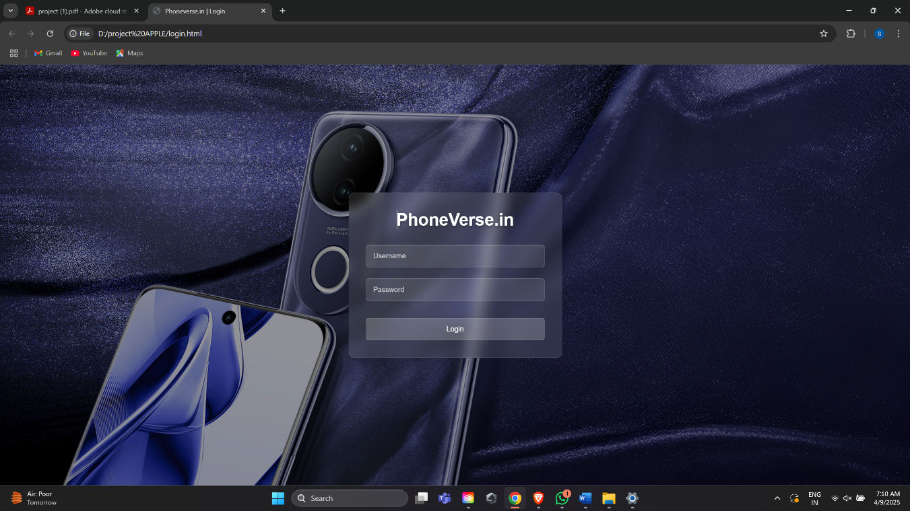

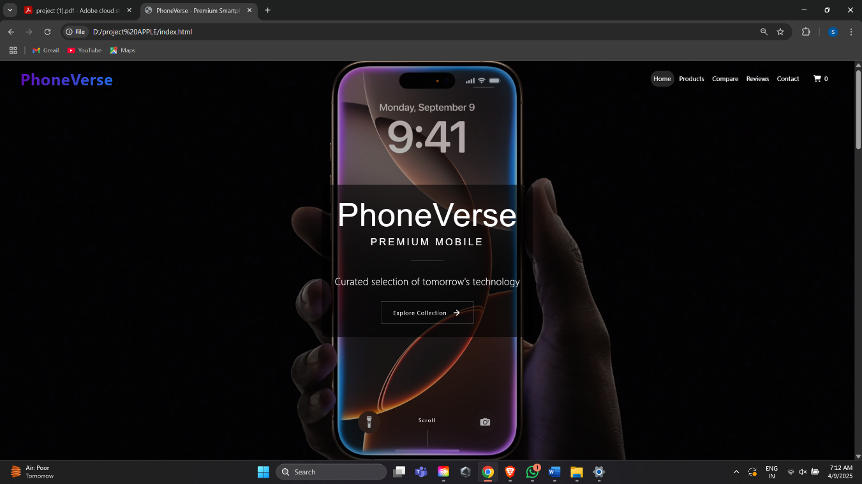

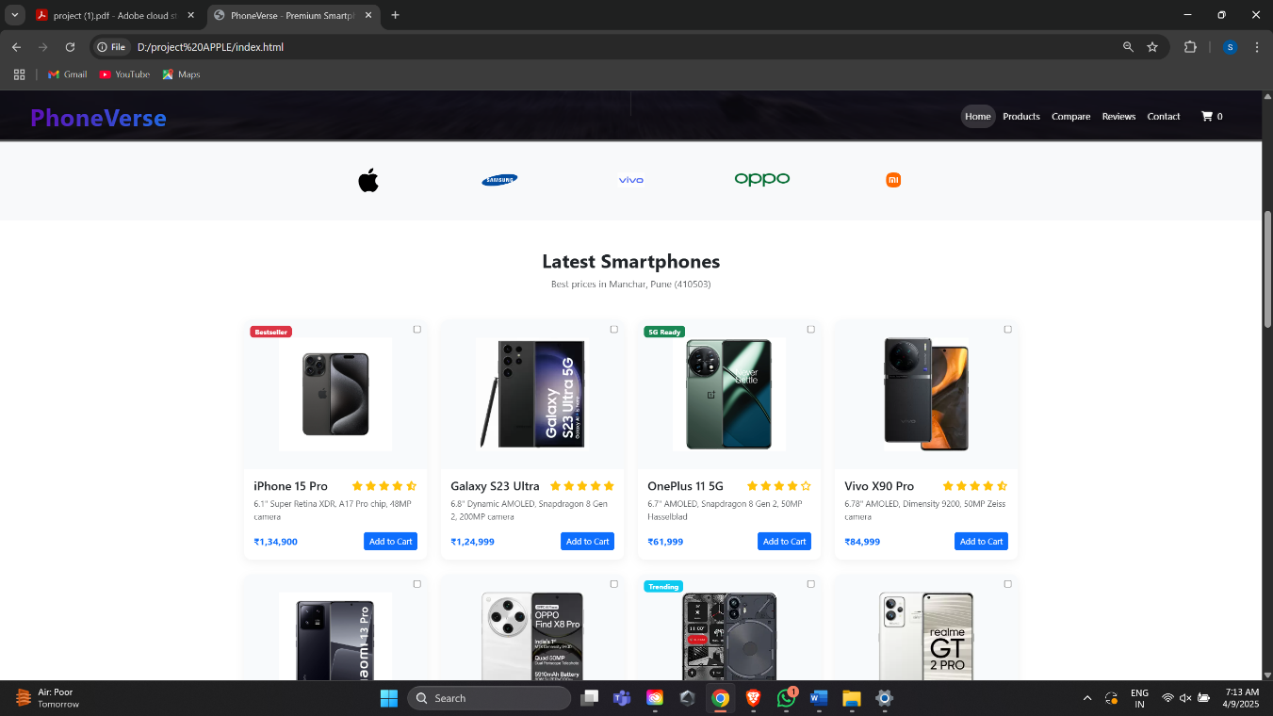

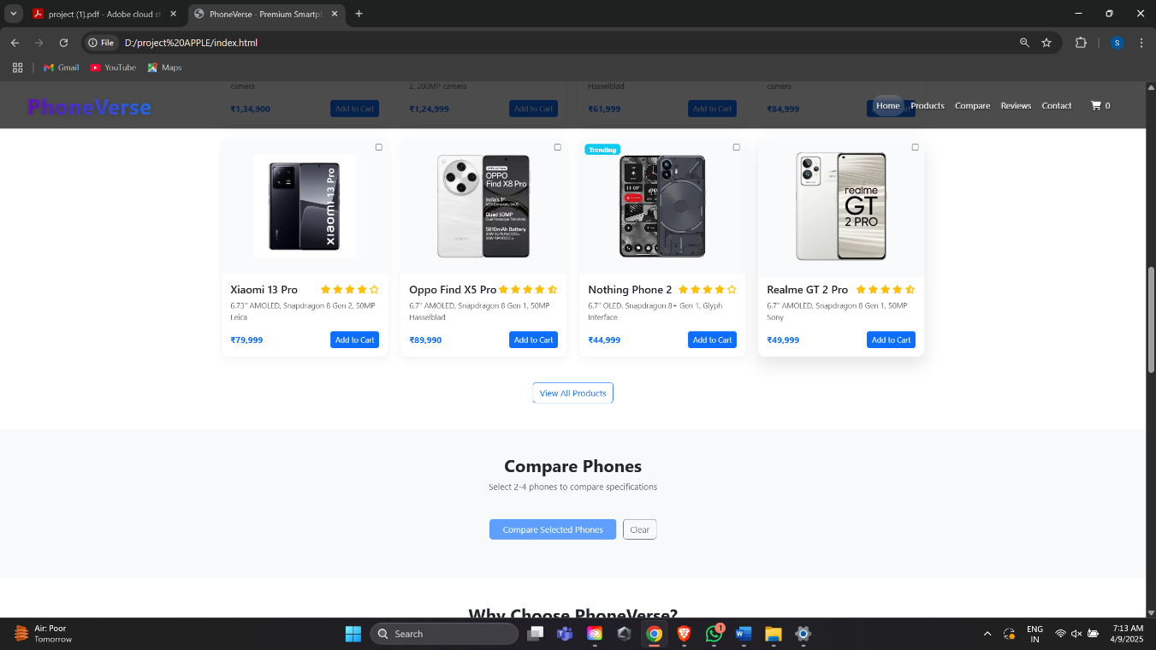

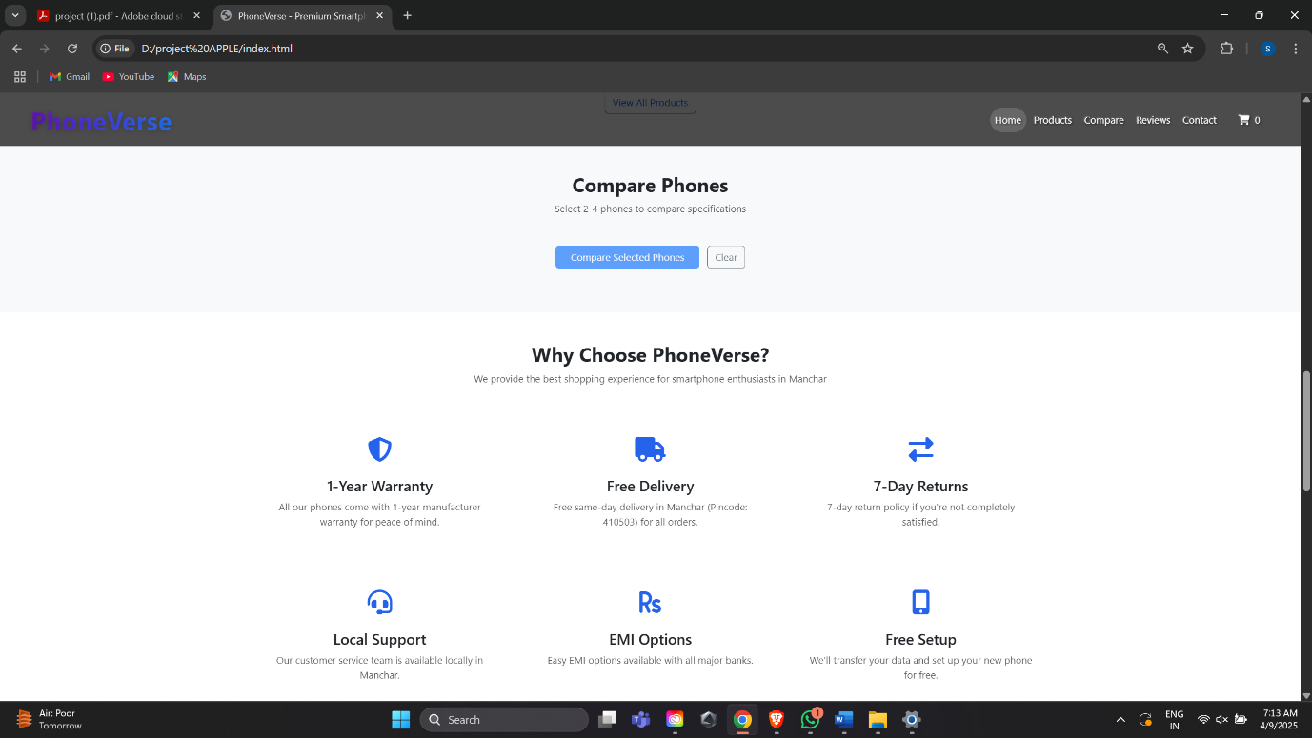

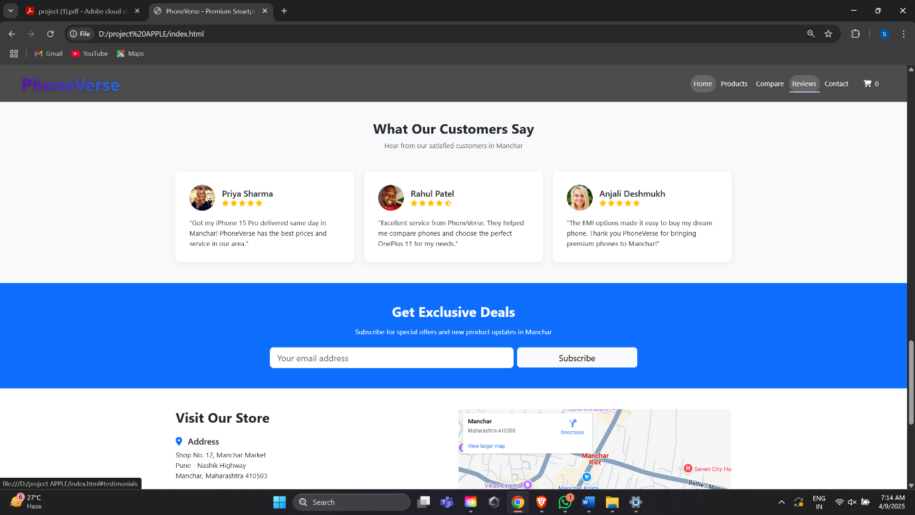

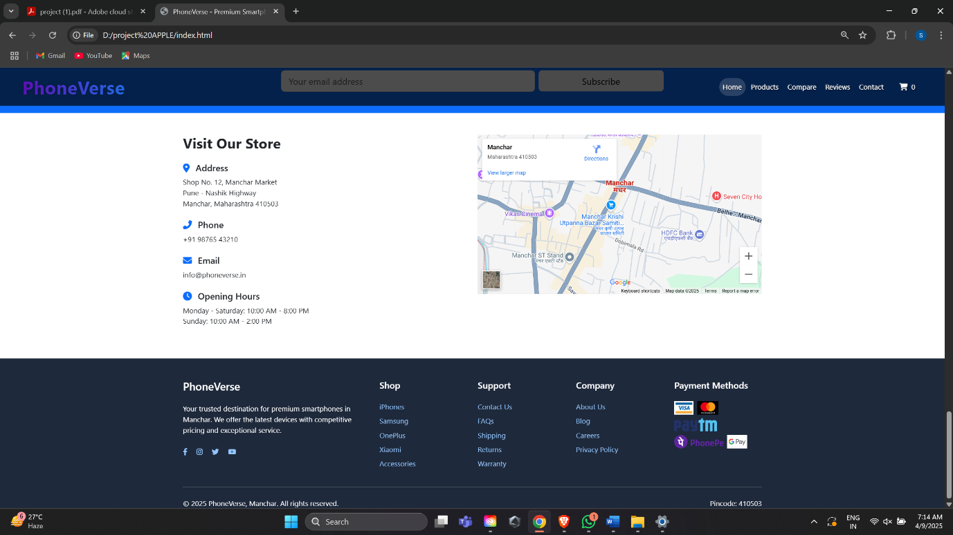

**ADVANTAGES & DISADVANTAGES**

* **ADVANTAGES**

## User-Friendly Interface-

The platform provides a simple and intuitive interface, making it easy for customers to browse the menu, add items to the cart, and place orders.

## Convenience & Accessibility-

Customers can order food from anywhere at any time, eliminating the need to visit a restaurant physically.

## Dynamic Shopping Cart-

The system allows users to modify quantities, apply discount coupons, and see real-time pricing updates before checkout

## Improved Order Accuracy-

By collecting customer details such as name, phone number, address, and email, the system minimizes errors in delivery.

## Enhanced Customer Engagement-

## The review system allows customers to leave feedback, improving trust and helping businesses enhance their services.

## Cost-Effective Solution-

## The website is built using HTML, CSS, and JavaScript, requiring no backend infrastructure, making it easy to maintain and deploy.

* **Scalability for Future Enhancements** –

The system can be expanded with additional features like online payment integration, real-time order tracking, and AI-based food recommendations.

* **Business Growth & Online Presence** –

Restaurants and food vendors can attract more customers, boost sales, and establish a strong digital presence.

* **Secure and Privacy-Friendly** –

The system does not store sensitive user data, ensuring compliance with data protection laws

## DISADVANTAGES

* **No Backend Support :**

Since the system is built using only HTML, CSS, and JavaScript, there is no database to store user orders, past transactions, or customer details for future reference.

* **Dependence on Local Storage** –

The cart system works only within the session, meaning that once the page is refreshed, the cart data is lost.

## Increased Internet Time:

This generation of technology users are already spending an excessive amount of screen time, and online shoot only makes this worse. It’s easy to sucked into staying longer than planned on the internet when shopping online. This is probably because of all the amazing offers and products available on online stores.

* **Security Concerns** –

Since there is no authentication or user verification system, anyone can place an order without identity validation, which may lead to fraudulent entries.

# FUTURE ENHANCEMENT

* Enhanced Security & Data Protection
* Advanced Payment Integration
* Voice Commerce Technology
* AR/VR Shopping Tools
* Voice Commerce Technology
* Social Commerce Integration

# BIBILOGRAPHY

* You tube - https://youtu.be/CQZxeoQeo5c?si=QgjOtx1m_zJFG0E-
* Google